**CSA0593**

**DATABASE MANAGEMENT SYSTEM**

*PRAKALYA P V*

*192311418*

*ASSIGNMENT - 3*

Healthcare Insurance Claims Processing System Database

- Design tables for patients, providers, claims, payments, and insurance plans.

- Implement stored procedures for claims submission, processing, and payment.

- Develop SQL queries for reporting claims status, provider performance, and payment summaries.

- Implement ACID properties to ensure reliable data management.

- Test using various failure scenarios.

1). Below is a database design for a **Healthcare Insurance Claims Processing System** with tables for managing **patients, providers, claims, payments,** and **insurance plans**. This design will support the submission, processing, and payment of healthcare insurance claims.

**Database Design:**

1. **Table for Patients:-**

CREATE TABLE Patients (

patient_id INT PRIMARY KEY AUTO_INCREMENT,

first_name VARCHAR(50) NOT NULL,

last_name VARCHAR(50) NOT NULL,

date_of_birth DATE NOT NULL,

gender CHAR(1) CHECK (gender IN ('M', 'F', 'O')), -- M=Male, F=Female, O=Other

insurance_plan_id INT,

address VARCHAR(255),

phone_number VARCHAR(20),

email VARCHAR(100),

FOREIGN KEY (insurance_plan_id) REFERENCES InsurancePlans(insurance_plan_id) ON DELETE SET NULL

);

1. **Table for Providers:-**

CREATE TABLE Providers (

provider_id INT PRIMARY KEY AUTO_INCREMENT,

provider_name VARCHAR(100) NOT NULL,

specialty VARCHAR(50),

contact_number VARCHAR(20),

email VARCHAR(100),

address VARCHAR(255),

provider_type ENUM('Hospital', 'Clinic', 'Individual', 'Pharmacy') NOT NULL

);

1. **Table for Insurance Plans:-**

CREATE TABLE InsurancePlans (

insurance_plan_id INT PRIMARY KEY AUTO_INCREMENT,

plan_name VARCHAR(100) NOT NULL,

coverage_percentage DECIMAL(5, 2) NOT NULL CHECK (coverage_percentage BETWEEN 0 AND 100),

deductible DECIMAL(10, 2) NOT NULL,

max_coverage_amount DECIMAL(15, 2) NOT NULL,

description TEXT

);

**4.Table for Claims:-**

CREATE TABLE Claims (

claim_id INT PRIMARY KEY AUTO_INCREMENT,

patient_id INT NOT NULL,

provider_id INT NOT NULL,

service_date DATE NOT NULL,

claim_amount DECIMAL(15, 2) NOT NULL,

status ENUM('Submitted', 'Processing', 'Approved', 'Rejected', 'Paid') DEFAULT 'Submitted',

insurance_coverage_amount DECIMAL(15, 2),

patient_responsible_amount DECIMAL(15, 2),

submission_date TIMESTAMP DEFAULT CURRENT_TIMESTAMP,

FOREIGN KEY (patient_id) REFERENCES Patients(patient_id) ON DELETE CASCADE,

FOREIGN KEY (provider_id) REFERENCES Providers(provider_id) ON DELETE SET NULL

);

**5.Table for Payments:-**

CREATE TABLE Payments (

payment_id INT PRIMARY KEY AUTO_INCREMENT,

claim_id INT NOT NULL,

payment_date TIMESTAMP DEFAULT CURRENT_TIMESTAMP,

amount DECIMAL(15, 2) NOT NULL,

payment_method ENUM('Bank Transfer', 'Check', 'Credit Card') NOT NULL,

FOREIGN KEY (claim_id) REFERENCES Claims(claim_id) ON DELETE CASCADE

);

**RELATIONS:-**

* **Patients and Providers**: Patients receive healthcare services from providers. Each claim ties a patient to a provider, helping track who rendered the service.
* **Insurance Plans and Claims**: Each patient is associated with an insurance plan. The insurance plan determines the coverage percentage, deductible, and maximum coverage amount for claims. These details are used to calculate the insurance and patient portions for each claim.
* **Claims and Payments**: A claim may result in one or multiple payments. Payments table links each payment to a specific claim, capturing the details of financial transactions for each claim.

2). Below are stored procedures for **claims submission**, **claims processing**, and **claims payment**. These procedures will automate the claim-related processes, such as submitting claims, processing them (approving/rejecting), and making payments.

**Stored Procedure for Claims Submission.**

DELIMITER $$

CREATE PROCEDURE SubmitClaim (

IN p_patient_id INT,

IN p_provider_id INT,

IN p_service_date DATE,

IN p_claim_amount DECIMAL(15, 2)

)

BEGIN

DECLARE v_coverage_percentage DECIMAL(5, 2);

DECLARE v_deductible DECIMAL(10, 2);

DECLARE v_max_coverage DECIMAL(15, 2);

DECLARE v_insurance_coverage DECIMAL(15, 2);

DECLARE v_patient_responsible DECIMAL(15, 2);

-- Fetch insurance plan details

SELECT coverage_percentage, deductible, max_coverage_amount

INTO v_coverage_percentage, v_deductible, v_max_coverage

FROM Patients p

JOIN InsurancePlans i ON p.insurance_plan_id = i.insurance_plan_id

WHERE p.patient_id = p_patient_id;

-- Calculate insurance coverage and patient responsibility

IF p_claim_amount > v_deductible THEN

SET v_insurance_coverage = LEAST(p_claim_amount - v_deductible, v_max_coverage) * (v_coverage_percentage / 100);

SET v_patient_responsible = p_claim_amount - v_insurance_coverage;

ELSE

SET v_insurance_coverage = 0;

SET v_patient_responsible = p_claim_amount;

END IF;

-- Insert the claim into Claims table

INSERT INTO Claims (patient_id, provider_id, service_date, claim_amount, insurance_coverage_amount, patient_responsible_amount)

VALUES (p_patient_id, p_provider_id, p_service_date, p_claim_amount, v_insurance_coverage, v_patient_responsible);

END $$

DELIMITER ;

**Stored Procedure for Claims Processing.**

DELIMITER $$

CREATE PROCEDURE ProcessClaim (

IN p_claim_id INT

)

BEGIN

DECLARE v_claim_amount DECIMAL(15, 2);

DECLARE v_max_coverage DECIMAL(15, 2);

DECLARE v_patient_id INT;

DECLARE v_status ENUM('Submitted', 'Processing', 'Approved', 'Rejected', 'Paid');

-- Fetch the claim details

SELECT claim_amount, patient_id

INTO v_claim_amount, v_patient_id

FROM Claims

WHERE claim_id = p_claim_id;

-- Fetch the insurance plan details (e.g., max coverage amount)

SELECT max_coverage_amount

INTO v_max_coverage

FROM Patients p

JOIN InsurancePlans i ON p.insurance_plan_id = i.insurance_plan_id

WHERE p.patient_id = v_patient_id;

-- Determine claim status based on amount and max coverage

IF v_claim_amount <= v_max_coverage THEN

SET v_status = 'Approved';

ELSE

SET v_status = 'Rejected';

END IF;

-- Update claim status

UPDATE Claims

SET status = v_status

WHERE claim_id = p_claim_id;

-- Optionally, update patient last activity (or create a trigger for this)

UPDATE Users

SET last_activity = NOW()

WHERE user_id = v_patient_id;

END $$

DELIMITER ;

**Stored Procedure for Claims Payment.**

DELIMITER $$

CREATE PROCEDURE ProcessPayment (

IN p_claim_id INT,

IN p_payment_method ENUM('Bank Transfer', 'Check', 'Credit Card'),

IN p_payment_amount DECIMAL(15, 2)

)

BEGIN

DECLARE v_claim_amount DECIMAL(15, 2);

DECLARE v_patient_responsible DECIMAL(15, 2);

DECLARE v_insurance_coverage DECIMAL(15, 2);

DECLARE v_status ENUM('Paid', 'Processing', 'Approved', 'Rejected');

-- Fetch claim details

SELECT claim_amount, patient_responsible_amount, insurance_coverage_amount, status

INTO v_claim_amount, v_patient_responsible, v_insurance_coverage, v_status

FROM Claims

WHERE claim_id = p_claim_id;

-- Ensure the claim is approved before payment

IF v_status = 'Approved' THEN

-- Insert payment record

INSERT INTO Payments (claim_id, payment_date, amount, payment_method)

VALUES (p_claim_id, NOW(), p_payment_amount, p_payment_method);

-- Update claim status to Paid

UPDATE Claims

SET status = 'Paid'

WHERE claim_id = p_claim_id;

ELSE

SIGNAL SQLSTATE '45000' SET MESSAGE_TEXT = 'Claim is not approved or is in invalid state for payment.';

END IF;

END $$

DELIMITER ;

* These stored procedures help automate critical processes in the healthcare insurance claims workflow, ensuring that claims are handled efficiently and accurately.

3). Here are several SQL queries for reporting on **claims status**, **provider performance**, and **payment summaries** within a Healthcare Insurance Claims Processing System. These reports will help administrators and managers track the status of claims, analyse the performance of providers, and summarize payment information.

**1. Query for Reporting Claims Status**

This query generates a summary of claims grouped by their status (Submitted, Processing, Approved, Rejected, Paid). It provides the total number of claims and the total claim amounts for each status.

SELECT

status AS claim_status,

COUNT(*) AS total_claims,

SUM(claim_amount) AS total_claim_amount,

SUM(insurance_coverage_amount) AS total_insurance_coverage,

SUM(patient_responsible_amount) AS total_patient_responsible

FROM Claims

GROUP BY status

ORDER BY total_claims DESC;

### 2. ****Query for Reporting Provider Performance****

This query provides a report on how each healthcare provider is performing by summarizing the number of claims they’ve processed, the total claim amounts, and the total insurance coverage amounts.

SELECT

p.provider_name,

COUNT(c.claim_id) AS total_claims,

SUM(c.claim_amount) AS total_claim_amount,

SUM(c.insurance_coverage_amount) AS total_insurance_coverage,

AVG(c.insurance_coverage_amount) AS avg_coverage_per_claim

FROM Claims c

JOIN Providers p ON c.provider_id = p.provider_id

GROUP BY p.provider_name

ORDER BY total_claims DESC;

### 3. ****Query for Reporting Payment Summaries****

This query provides a summary of payments made, including the total payment amount, grouped by payment method (Bank Transfer, Check, Credit Card). It shows the total payments for each method.

SELECT

payment_method,

COUNT(*) AS total_payments,

SUM(amount) AS total_payment_amount,

AVG(amount) AS avg_payment_amount

FROM Payments

GROUP BY payment_method

ORDER BY total_payment_amount DESC;

* These SQL queries allow you to generate various reports that help administrators manage healthcare insurance claims, track provider performance, and summarize payment activity. They offer insights into the overall claims process, from submission to payment, and are critical for effective decision-making, billing, and auditing within a healthcare insurance system.

4) **Implement ACID properties to ensure reliable data management** :

To ensure reliable data management in a **Healthcare Insurance Claims Processing System Database**, implementing **ACID properties** is essential.

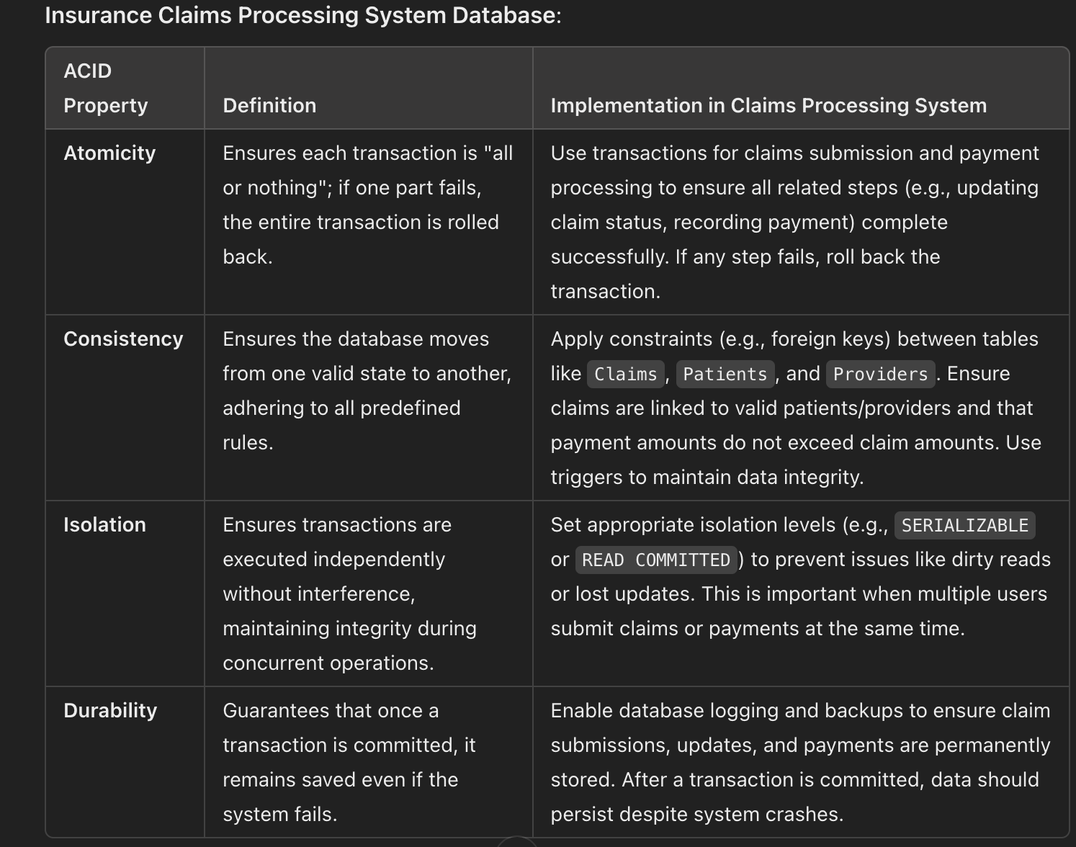

5.) **Test using various failure scenarios:**

To ensure the **Healthcare Insurance Claims Processing System Database** meets ACID properties, we can simulate various failure scenarios

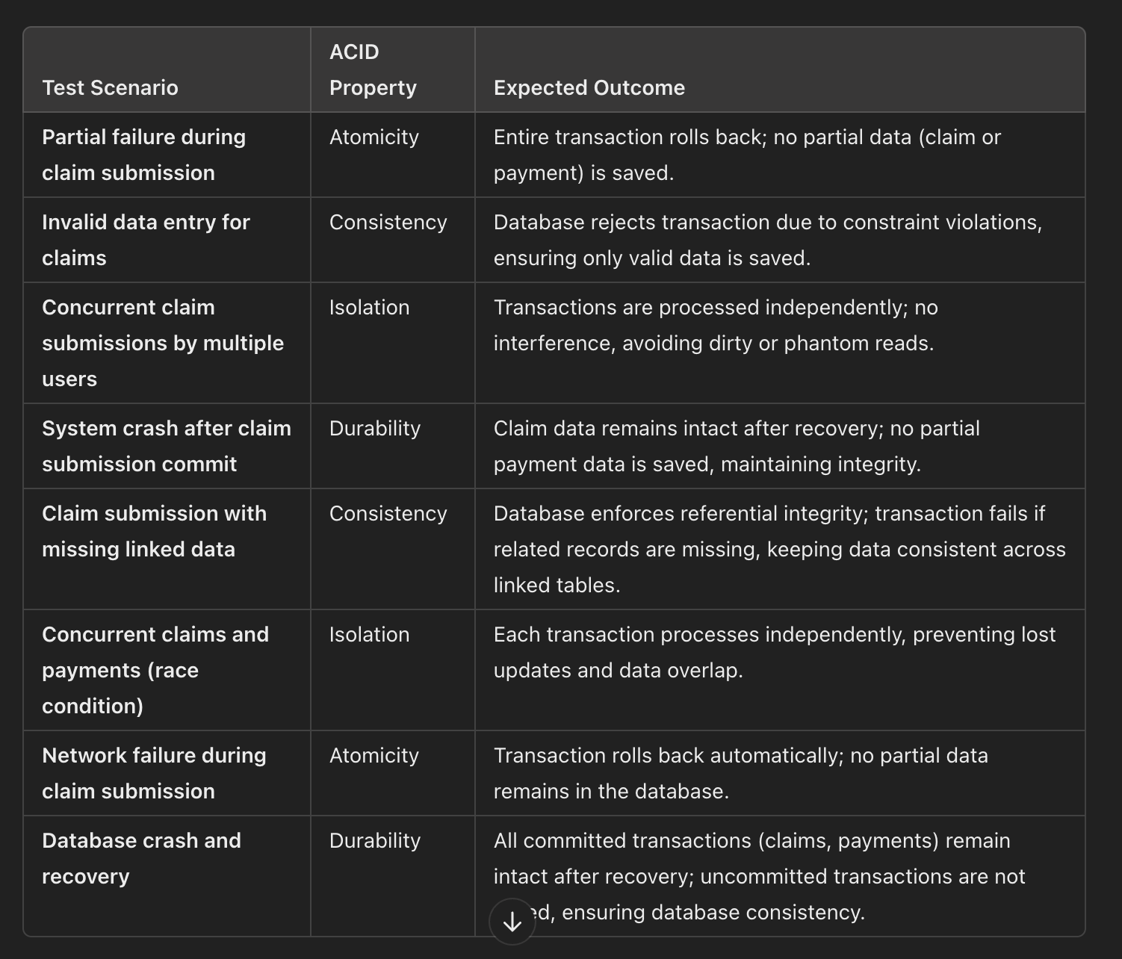

**CONCLUSION :**

In conclusion, implementing and rigorously testing ACID properties in the **Healthcare Insurance Claims Processing System Database** ensures a robust and reliable system for managing sensitive healthcare data. By addressing **Atomicity**, **Consistency**, **Isolation**, and **Durability**, the database can handle various failure scenarios gracefully, maintaining data integrity and reliability even under unexpected conditions. Atomicity guarantees that each transaction completes fully or not at all, avoiding partial data issues. Consistency enforces valid states by upholding constraints and relationships across tables, ensuring data accuracy. Isolation enables concurrent processing without conflicts, essential for high-transaction environments, while Durability ensures data permanence and recoverability in case of system failures.

These ACID-compliant strategies provide a strong foundation for secure, dependable claims processing, making the system well-suited for critical healthcare operations where data integrity is paramount.